# **CHAPTER – 1**

**INTRODUCTION**

* 1. **About the project:**

An enormous number of deaths occur every year as a result of heart disease, making it a major concern in world health. Improving patient outcomes and lowering death rates, early detection and correct diagnosis of cardiac disease play a key role. When the heart's arteries become blocked, oxygen-poor blood cannot reach the heart properly, resulting in coronary heart disease. Early detection of cardiac disease is viable because it reduces medical costs and potentially saves the patient's life. Recently presented methods have improved heart failure detection accuracy on testing data without sacrificing accuracy on training data, yet most of these algorithms are suffering from the issue of overfitting. Models that were created end up fitting the test data too well. In this study, we create a novel diagnostic system to address this issue, and the resulting system demonstrates high intelligence and excellent performance on both training and testing data. Machine learning (ML) algorithms have demonstrated promising potential in assisting healthcare professionals with timely and accurate diagnosis. In this paper, is based on supervised machine learning methods are decision tree (DT), random forest (RF), Support vector Machine (SVM), Principal Component Analysis(PCA). We compare their accuracy with each other by using bar plot.

One of the critical issues in medical data analysis is accurately predicting a patient’s risk of heart disease, which is vital for early intervention and reducing mortality rates. Early detection allows for timely treatment and continuous monitoring by healthcare providers, which is essential but often limited by the inability of medical professionals to provide constant patient supervision. Early detection of cardiac problems and continuous patient monitoring by physicians can help reduce death rates. Doctors cannot constantly have contact with patients, and heart disease detection is not always accurate. By offering a more solid foundation for prediction and decision-making based on data provided by healthcare sectors worldwide, machine learning (ML) could help physicians with the prediction and detection of HD. This study aims to use different feature selection strategies to produce an accurate ML algorithm for early heart disease prediction. We have chosen features using chi-square, ANOVA, and mutual information methods. The three feature groups chosen were SF-1, SF-2, and SF-3. The study employed ten machine learning algorithms to determine the most accurate technique and feature subset fit. The classification algorithms used include support vector machines (SVM), XGBoost, bagging, decision trees (DT), and random forests (RF). We evaluated the proposed heart disease prediction technique using a private dataset, a public dataset, and different cross-validation methods. We used the Synthetic Minority Oversampling Technique (SMOTE) to eliminate inconsistent data and discover the machine learning algorithm that achieves the most accurate heart disease predictions. Healthcare providers might identify early-stage heart disease quickly and cheaply with the proposed method. We have used the most effective ML algorithm to create a mobile app that instantly predicts heart disease based on the input symptoms. The experimental results demonstrated that the XGBoost algorithm performed optimally when applied to the combined datasets and the SF-2 feature subset. It had 97.57% accuracy, 96.61% sensitivity, 90.48% specificity, 95.00% precision, a 92.68% F1 score, and a 98% AUC. We have developed an explainable AI method based on SHAP approaches to understand how the system makes its final predictions.

# **CHAPTER – 2**

**SYSTEM ANALYSIS**

**2.1. Existing System:**

Existing systems for heart disease prediction generally rely on traditional statistical methods, such as logistic regression, decision trees, and rule-based systems. These systems use features like age, cholesterol levels, blood pressure, family history, and smoking habits to estimate the likelihood of heart disease.

**Drawbacks of Existing Systems:**

* **Limited Accuracy:** Traditional methods often fail to capture complex patterns in the data, leading to inaccurate predictions, especially for patients with atypical symptoms or those at an early stage of the disease.
* **Data Dependency:** These models require a significant amount of manual input and depend on the availability of complete data, which may not always be accessible or accurate.
* **Inflexibility:** Most existing systems are static and unable to adapt to new data or changes in patient conditions. This limits their ability to provide personalized healthcare solutions.
* **Risk of Overfitting**: Many traditional methods can overfit the data, meaning they perform well on the training data but fail to generalize to new or unseen patient data.
* **Limited Scope:** Existing systems may not consider a wide range of factors (e.g., genetic information, lifestyle data) that could contribute to a more accurate prediction of heart disease.

**2.2 Proposed System:**

The proposed system for heart disease prediction using Machine Learning (ML) aims to overcome the limitations of traditional methods by employing more advanced techniques, including supervised learning algorithms like Random Forest, Support Vector Machines (SVM), and Neural Networks. The system would integrate a wide range of data, including clinical factors, lifestyle data, genetic information, and even real-time health monitoring (e.g., heart rate, activity levels) from wearable devices.

**Advantages**:

* Improved Accuracy: ML models can learn complex relationships between variables, leading to more accurate predictions than traditional methods. These models can identify subtle patterns in data that may not be easily noticeable.
* Personalization: The system can provide personalized predictions based on an individual’s medical history, lifestyle choices, and genetic factors, offering tailored insights and recommendations.
* Adaptability: As more data becomes available over time, ML models can continuously learn and adapt, improving their predictive power. This makes the system capable of adjusting to changes in patient conditions and evolving trends in healthcare.
* Incorporation of Multiple Data Sources: The proposed system can integrate a broader range of data sources, including electronic health records (EHR), wearable devices, and real-time health data, providing a more holistic view of a patient's health.
* Early Detection: With the ability to analyze large and diverse datasets, the system could detect early signs of heart disease in individuals who may not yet show clear symptoms, enabling early intervention and preventive care.
* Reduction in Human Error: By automating the prediction process, the system reduces the reliance on manual input, which can be error-prone, and ensures more consistent and accurate results.
* Scalability: The system could easily scale to accommodate large datasets from diverse populations, improving its robustness and generalization across different demographics.
* Real-Time Monitoring: Integrating with wearable devices (e.g., fitness trackers, smartwatches) would allow for continuous monitoring of heart health metrics like heart rate, blood pressure, and physical activity, offering real-time insights into the risk of heart disease.

**2.3 Module Description:**

The system is divided into several modules, each handling a specific aspect of the cybersecurity workflow. Below is a detailed description of the core modules and their functionalities:

**1. NumPy (numpy)**

* **Numerical computing library** that provides support for arrays and matrices, along with a wide range of mathematical functions to operate on these arrays.

**Usage:**

* Handling large datasets in machine learning projects.
* Numerical operations on data, such as matrix manipulations.

**2. Pandas (pandas)**

* **Data manipulation and analysis** library used for working with structured data, such as CSV files, Excel spreadsheets, and SQL databases.

**Usage:**

* Data cleaning, exploration, and preparation for machine learning models.

**3. Scikit-learn (sklearn)**

* **Machine learning library** that provides simple tools for data analysis and modeling. It includes a wide variety of algorithms for classification, regression, clustering, and dimensionality reduction.

**Usage:**

* Building and evaluating machine learning models in classification, regression, and clustering tasks.

**4. Seaborn (seaborn)**

* **Data visualization library** built on top of Matplotlib, which makes it easy to create attractive and informative statistical graphics.

**Usage:**

* Creating insightful and visually appealing plots for data exploration and presentation.

**5. Matplotlib (matplotlib)**

* **2D plotting library** used for creating static, animated, and interactive visualizations.

**Usage:**

* Basic plotting for visualizing datasets and model outputs.

**7. TensorFlow (tensorflow)**

* **Open-source machine learning** framework that allows the creation and deployment of machine learning models, especially deep learning models.

**Usage:**

* Building deep learning models, training, and deploying them on cloud or edge devices.

**2.4 Feasibility Study:**

**1. Introduction**

Heart disease is one of the leading causes of death worldwide, making early diagnosis and prediction critical for improving patient outcomes. Machine learning (ML) offers significant potential to enhance heart disease prediction by leveraging historical health data, medical records, and diagnostic information. This feasibility study evaluates the technical, economic, operational, and legal aspects of implementing a heart disease prediction system using ML.

**2. Technical Feasibility**

The technical feasibility of this system hinges on the availability of high-quality, diverse datasets, such as patient demographic details, lifestyle factors, clinical measurements (e.g., cholesterol, blood pressure), and previous diagnoses. Machine learning algorithms, particularly classification models like logistic regression, decision trees, random forests, and support vector machines (SVM), can be used to analyze this data and predict the likelihood of heart disease.

* **Data Availability:** Data from medical records, health databases, and public datasets (e.g., UCI Heart Disease dataset) are readily available, making the data collection process feasible.
* **Data Preprocessing:** Feature selection, handling missing values, and normalizing data are essential preprocessing steps that are well-supported by ML libraries like Pandas, NumPy, and Scikit-learn.
* **Model Implementation:** Models can be developed using popular ML frameworks such as TensorFlow, Keras, and Scikit-learn, with training and evaluation based on various performance metrics like accuracy, precision, recall, and F1 score.
* **Computational Resources:** The system will require minimal computational resources for training, especially when using relatively simple models. However, more complex models, such as neural networks, may need additional hardware resources, including high-performance processors or cloud computing infrastructure.

**3. Economic Feasibility**

The economic feasibility of this project depends on the cost of data collection, processing, model training, and implementation. The project can be broken down into the following costs:

* **Initial Development Costs:** These include the costs associated with data acquisition, cleaning, and preprocessing, along with the development of the ML model and system deployment.
* **Ongoing Costs:** Maintenance of the system, data updates, and periodic model retraining are essential to ensure the system remains accurate and up-to-date with the latest health trends.
* **Cost Reduction:** ML-driven heart disease prediction could reduce the need for expensive, time-consuming diagnostic tests and hospital visits. It can also lead to earlier detection and treatment, ultimately reducing healthcare costs associated with heart disease.

**4. Operational Feasibility**

Operational feasibility evaluates how effectively the system can be integrated into existing healthcare infrastructure:

* **Integration with Healthcare Systems:** The ML model can be integrated with existing Electronic Health Record (EHR) systems and clinical decision support tools, allowing healthcare professionals to use the prediction model seamlessly in real-time.
* **User Accessibility:** The system should be designed for ease of use by medical professionals, with a user-friendly interface for inputting patient data and interpreting predictions.
* **Training and Support:** Medical personnel will need training on how to use the system effectively. Additionally, continuous support will be required to maintain the system’s functionality and adapt to new healthcare guidelines and research.
* **Real-Time Predictions:** The system could offer real-time predictions for patients, aiding clinicians in decision-making during consultations or emergency situations.

**5. Legal and Ethical Feasibility**

Given the sensitive nature of healthcare data, legal and ethical considerations are paramount:

* **Data Privacy and Security**: The system must comply with privacy regulations such as HIPAA (Health Insurance Portability and Accountability Act) in the U.S., GDPR (General Data Protection Regulation) in Europe, and similar laws worldwide. Data encryption, access control, and secure storage protocols will be essential to protect patient information.
* **Bias and Fairness:** The system must be trained on diverse and representative datasets to ensure that it does not exhibit bias toward specific demographics (e.g., age, gender, ethnicity). Fairness in prediction is critical to avoid misdiagnosis or unequal treatment recommendations.
* **Informed Consent:** Patients must be informed about how their data will be used for ML modeling and predictions. They should have the option to opt out if they prefer not to share their information for this purpose.
* Regulatory Approval: If the system is to be used as a clinical tool, it will need approval from relevant regulatory bodies (e.g., FDA in the U.S., CE Mark in Europe) before it can be widely deployed in healthcare settings.

**6. Conclusion**

The Heart Disease Prediction System Using Machine Learning is technically feasible, with access to the necessary data and powerful machine learning frameworks that can generate accurate predictions. Economically, the system has the potential to reduce healthcare costs through earlier detection and better resource allocation. Operationally, the system can integrate into existing healthcare workflows, benefiting both clinicians and patients. Legally, it must comply with healthcare data privacy laws and ensure fairness in its predictions. With careful planning, data governance, and system integration, this ML-driven heart disease prediction system can make a significant impact on public health and improve patient outcomes.

CHAPTER - 3

**REQUIREMENT ANALYSIS**

**HARDWARE SYSTEM REQUIREMENTS:**

**➢ System :Pentium i3 Processor.**

**➢ Hard Disk : 500 GB.**

**➢ Monitor: 15’’ LED**

**➢ Input Devices: Keyboard, Mouse**

**➢ Ram: 4 GB**

**SOFTWARE SYSTEM REQUIREMENTS:**

**➢Operating system : Windows 10 .**

**➢ Coding Language:Python Web**

**➢ Web Framework :Flask**

**3.3 functional Requirements:**

1. **Data Collection and Preprocessing:**
   * The system should allow the collection of patient data, including factors like age, gender, blood pressure, cholesterol levels, ECG results, and lifestyle data.
   * It should be capable of cleaning, normalizing, and transforming raw data into a usable format for model training.
2. **Model Training:**
   * The system should allow the selection and training of machine learning models (e.g., Logistic Regression, Decision Trees, Random Forests, SVM, etc.) on historical health data to predict heart disease risk.
   * The model should be capable of evaluating performance metrics like accuracy, precision, recall, and F1 score for validation.
3. **Prediction:**
   * The system should provide an interface for inputting patient data and generating real-time predictions regarding heart disease risk.
   * It should predict whether the patient is at risk of heart disease (yes/no) based on input health metrics.
4. **Visualization:**
   * The system should offer visualization tools for displaying prediction results (e.g., pie charts, bar graphs, or risk scores) to help clinicians interpret outcomes.
5. **Recommendation System:**
   * Based on the predicted risk, the system should offer lifestyle recommendations or refer patients to healthcare professionals for further diagnostic evaluation.
6. **User Interface:**
   * The system should have a user-friendly interface for clinicians and users to input and view patient data and predictions.
7. **Data Security:**
   * The system should ensure secure data storage and transmission, including encryption of sensitive patient data.
8. **Integration with Healthcare Systems:**
   * The system should integrate with existing Electronic Health Records (EHR) or hospital databases for seamless data retrieval.
   1. **Non-Functional Requirements:**
9. **Performance**:
   * The system should provide quick predictions (typically within a few seconds) after receiving the input data.
   * It should be able to handle large datasets and maintain consistent performance, even as the number of users or patients increases.
10. **Scalability**:
    * The system should be scalable to handle growing amounts of data over time, especially as the dataset of patient information expands.
11. **Reliability**:
    * The system should be reliable with minimal downtime, ensuring that it can provide accurate predictions whenever needed by healthcare professionals.

# **Usability**:

# The system should be easy to use for both healthcare professionals and patients with minimal training required. It should have an intuitive interface with clear instructions for data input and interpretation.

# **Security**:

# The system should adhere to relevant healthcare data privacy regulations such as HIPAA (in the US) or GDPR (in Europe), ensuring patient data is stored, transmitted, and accessed securely.

# Strong user authentication methods must be implemented to protect sensitive patient information.

# **Maintainability**:

# The system should be easy to maintain and update, including the ability to retrain machine learning models with new data to improve prediction accuracy.

# It should allow for bug fixes, software updates, and model enhancements without causing significant downtime.

# **Interoperability**:

# The system should be interoperable with existing healthcare systems, ensuring smooth data exchange and integration with EHR, lab test results, and other medical tools.

# **Portability**:

# The system should be portable across different platforms, whether on a web interface, mobile devices, or desktop computers, to ensure widespread accessibility.

# **Ethical Compliance**:

# The system must follow ethical guidelines to prevent biased predictions, especially ensuring fairness and equity in predicting heart disease risks across diverse populations.

# **Accuracy and Reliability of ML Model**:

# The predictions made by the system must be statistically reliable, with a high degree of accuracy to minimize false positives and false negatives, and to provide actionable insights.

# CHAPTER – 4

**SYSTEM DESIGN**

* 1. **System Architecture:**

The **Heart Disease Prediction System using Machine Learning** typically follows a structured architecture, consisting of several key components that work together to process data, build models, and provide accurate predictions. Below is an outline of the system architecture: 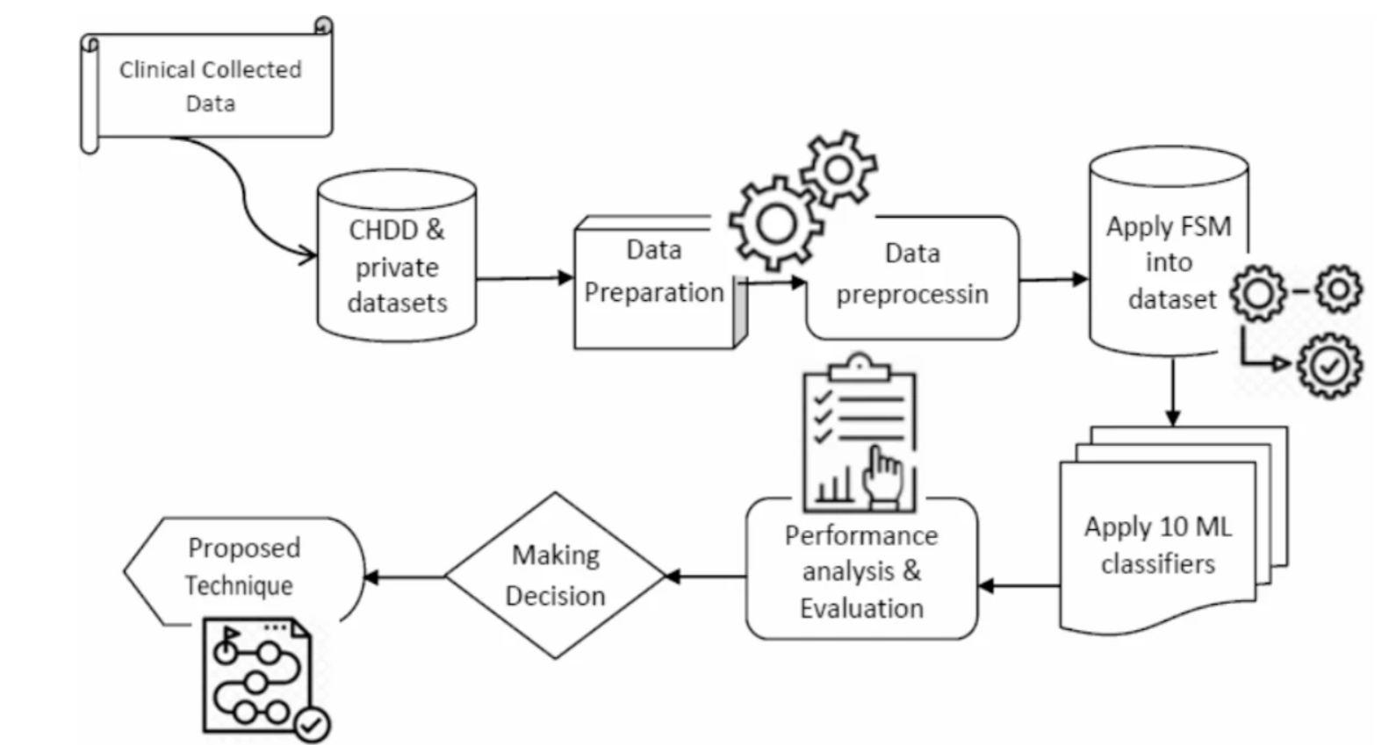

**Fig 4.1 System Architecture**

This architecture ensures that the heart disease prediction system is accurate, reliable, and scalable, providing essential insights for healthcare professionals and improving patient outcomes.

**4.3 Unified Modeling Language Design:**

UML stands for Unified Modeling Language. UML is a standardized generalpurpose modeling language in the field of object-oriented software engineering. The standard is managed, and was created by, the Object Management Group.

The goal is for UML to become a common language for creating models of object oriented computer software. In its current form UML is comprised of two major components: a Meta-model and a notation. In the future, some form of method or process may also be added to; or associated with, UML.

The Unified Modeling Language is a standard language for specifying,

Visualization, Constructing and documenting the artifacts of software system, as well as for business modeling and other non-software systems.

The UML represents a collection of best engineering practices that have proven successful in the modeling of large and complex systems.

The UML is a very important part of developing objects oriented software and the software development process. The UML uses mostly graphical notations to express the design of software projects.

**GOALS:**

The Primary goals in the design of the UML are as follows:

1. Provide users a ready-to-use, expressive visual modeling Language so that they can develop and exchange meaningful models.
2. Provide extendibility and specialization mechanisms to extend the core concepts.
3. Be independent of particular programming languages and development process.
4. Provide a formal basis for understanding the modeling language.
5. Encourage the growth of OO tools market.
6. Support higher level development concepts such as collaborations, frameworks, patterns and components.
7. Integrate best practices.

**4.3.1 Use Case Diagram:**

A use case diagram in the Unified Modeling Language (UML) is a type of behavioral diagram defined by and created from a Use-case analysis. Its purpose is to present a graphical overview of the functionality provided by a system in terms of actors, their goals (represented as use cases), and any dependencies between those use cases. The main purpose of a use case diagram is to show what system functions are performed for which actor. Roles of the actors in the system can be depicted.

**Fig 4.3 Use case Diagram for user**

**4.3.1 Class Diagram**

In software engineering, a class diagram in the Unified Modeling Language (UML) is a type of static structure diagram that describes the structure of a system by showing the system's classes, their attributes, operations (or methods), and the relationships among the classes. It explains which class contains information.

**Fig: 4.3.1 Class Diagram**

**4.3.3 Sequence Diagram**:

A sequence diagram represents the interaction between different objects in the system. The important aspect of a sequence diagram is that it is time-ordered. This means that the exact sequence of the interactions between the objects is represented step by step. Different objects in the sequence diagram interact with each other by passing "messages".

**Fig 4.5 Sequence Diagram for user**

**4.4 Input Design:**

Input design is a part of overall system design. The main objective during the input design is as given below:

* To produce a cost-effective method of input.
* To achieve the highest possible level of accuracy.
* To ensure that the input is acceptable and understood by the user.

**Input Stages**

The main input stages can be listed as below:

* Data recording
* Data transcription
* Data conversion
* Data verification
* Data control
* Data transmission
* Data validation
* Data correction

Input Types

It is necessary to determine the various types of inputs. Inputs can be categorized as follows:

* External inputs, which are prime inputs for the system.
* Internal inputs, which are user communications with the system.
* Operational, which are computer department’s communications to the system?
* Interactive, which are inputs entered during a dialogue.

**Input Media**

At this stage choice has to be made about the input media. To conclude about the input media consideration has to be given to;

* Type of input
* Flexibility of format
* Speed
* Accuracy
* Verification methods
* Rejection rates
* Ease of correction
* Storage and handling requirements
* Security
* Easy to use
* Portability

Keeping in view the above description of the input types and input media, it can be said that most of the inputs are of the form of internal and interactive. As

Input data is to be the directly keyed in by the user, the keyboard can be considered to be the most suitable input device.

**Error Avoidance**

At this stage care is to be taken to ensure that input data remains accurate form the stage at which it is recorded up to the stage in which the data is accepted by the system. This can be achieved only by means of careful control each time the data is handled.

**Error Detection**

Even though every effort is made to avoid the occurrence of errors, still a small proportion of errors is always likely to occur, these types of errors can be discovered by using validations to check the input data.

**Data Validation**

Procedures are designed to detect errors in data at a lower level of detail. Data validations have been included in the system in almost every area where there is a possibility for the user to commit errors. The system will not accept invalid data. Whenever an invalid data is keyed in, the system immediately prompts the user and the user has to again key in the data and the system will accept the data only if the data is correct. Validations have been included where necessary.

The system is designed to be a user friendly one. In other words the system has been designed to communicate effectively with the user. The system has been designed with popup menus.

**User Interface Design**

It is essential to consult the system users and discuss their needs while designing the user interface:

**User Interface Systems Can Be Broadly Clasified As:**

* User initiated interface the user is in charge, controlling the progress of the user/computer dialogue. In the computer-initiated interface, the computer selects the next stage in the interaction.
* Computer initiated interfaces

In the computer-initiated interfaces the computer guides the progress of the user/computer dialogue. Information is displayed and the user response of the computer takes action or displays further information.

**User Initiated Intergfaces**

User initiated interfaces fall into two approximate classes:

* Command driven interfaces: In this type of interface the user inputs commands or queries which are interpreted by the computer.
* Forms oriented interface: The user calls up an image of the form to his/her screen and fills in the form. The forms-oriented interface is chosen because it is the best choice.

**Computer-Initiated Interfaces**

The following computer – initiated interfaces were used:

* The menu system for the user is presented with a list of alternatives and the user chooses one; of alternatives.
* Questions – answer type dialog system where the computer asks question and takes action based on the basis of the users reply.

Right from the start the system is going to be menu driven, the opening menu displays the available options. Choosing one option gives another popup menu with more options. In this way every option leads the users to data entry form where the user can key in the data.

**Error Message Design**

The design of error messages is an important part of the user interface design. As user is bound to commit some errors or other while designing a system the system should be designed to be helpful by providing the user with information regarding the error he/she has committed.

This application must be able to produce output at different modules for different inputs.

**Performance Requirements**

Performance is measured in terms of the output provided by the application. Requirement specification plays an important part in the analysis of a system. Only when the requirement specifications are properly given, it is possible to design a system, which will fit into required environment. It rests largely in the part of the users of the existing system to give the requirement specifications because they are the people who finally use the system. This is because the requirements have to be known during the initial stages so that the system can be designed according to those requirements. It is very difficult to change the system once it has been designed and on the other hand designing a system, which does not cater to the requirements of the user, is of no use.

The requirement specification for any system can be broadly stated as given below:

* The system should be able to interface with the existing system.
* The system should be accurate.
* The system should be better than the existing system.
* The existing system is completely dependent on the user to perform all the duties.

**4.5 Output Design:**

Outputs from computer systems are required primarily to communicate the results of processing to users. They are also used to provides a permanent copy of the results for later consultation. The various types of outputs in general are:

* External Outputs, whose destination is outside the organization
* Internal Outputs whose destination is within organization and they are the
* User’s main interface with the computer.
* Operational outputs whose use is purely within the computer department.
* Interface outputs, which involve the user in communicating directly.

**Output Definition**

The outputs should be defined in terms of the following points:

* Type of the output
* Content of the output
* Format of the output
* Location of the output
* Frequency of the output
* Volume of the output
* Sequence of the output

It is not always desirable to print or display data as it is held on a computer. It should be decided as which form of the output is the most suitable.

CHAPTER - 5

**IMPLEMENTATION**

**5.1 Machine Learning Technology:**

Machine learning is a discipline that deals with programming the systems so as to make them automatically learn and improve with experience. Here, learning implies recognizing and understanding the input data and taking informed decisions based on the supplied data. It is very difficult to consider all the decisions based on all possible inputs. To solve this problem, algorithms are developed that build knowledge from a specific data and past experience by applying the principles of statistical science, probability, logic, mathematical optimization, reinforcement learning, and control theory.

**5..2 Steps Involved in Machine Learning:**

A machine learning project involves the following steps

* + Defining a Problem
  + Preparing Data
  + Evaluating Algorithms
  + Improving Results • Presenting Results

Machine Learning (ML) is an automated learning with little or no human intervention. It involves programming computers so that they learn from the available inputs. The main purpose of machine learning is to explore and construct algorithms that can learn from the previous data and make predictions on new input data.The input to a learning algorithm is training data, representing experience, and the output is any expertise, which usually takes the form of another algorithm that can perform a task. The input data to a machine learning system can be numerical, textual, audio, visual, or multimedia.

**5.3 Machine Learning vs. Traditional Programming:**

Traditional programming differs significantly from machine learning. In traditional programming, programmers code all the rules in consultation with an expert in the industry for which software is being developed. Each rule is based on a logical foundation; the machine will execute an output following the logical statement. When the system grows complex, more rules need to be written. It can quickly become sustainable to maintain.

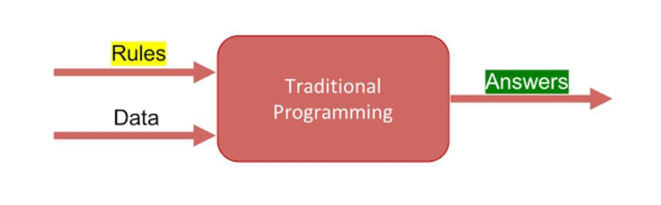

**Fig 5.1: Traditional Programming**

Machine learning is supposed to overcome this issue. The machine learns how the input and output data are correlated and it writes a rule. The programmers do not need to write new rules each time there is new data. The algorithms adapt in response to new data and experiences to improve efficacy over time.

## 

**5.2: Machine Learning**

**5.4 How does Machine learning work?**

Machine learning is the brain where all the learning takes place. The way the machine learns is similar to the human being. Humans learn from experience. The more we know, the more easily we can predict. By analogy, when we face an unknown situation, the likelihood of success is lower than the known situation. Machines are trained the same. To make an accurate prediction, the machine sees an example. When we give the machine a similar example, it can figure out the outcome. However, like a human, if it’s feed a previously unseen example, the machine has difficulties to predict.

5.5 Machine learning Algorithms and where they are used?

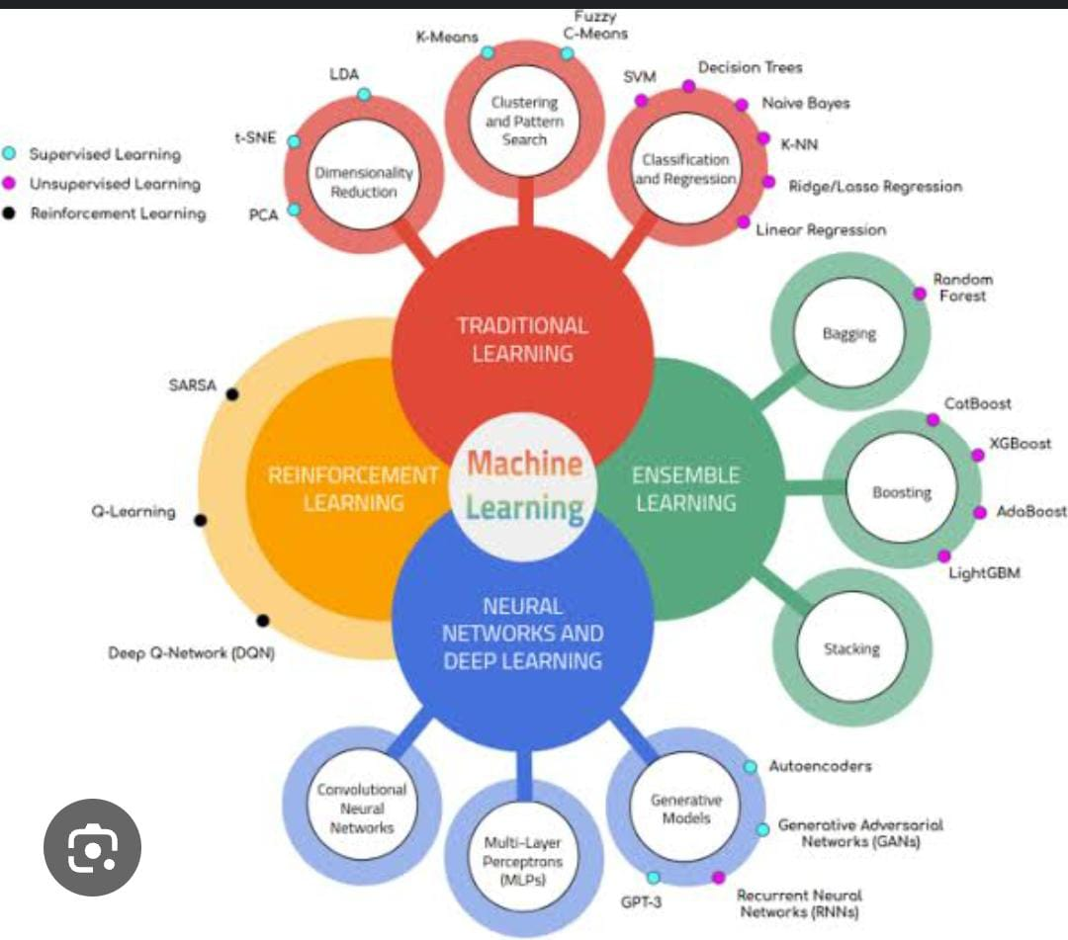

**Fig 5.3: Machine Learning Algorithms**

**5.6 Types of Machine Learning:**

There are four categories of machine learning algorithms as shown below

* Supervised learning algorithm
* Unsupervised learning algorithm
* Semi-supervised learning algorithm
* Reinforcement learning algorithm

**5.6.1 Supervised Learning:**

Supervised learning is commonly used in real world applications, such as face and speech recognition, products or movie recommendations, and sales forecasting.

Supervised learning can be further classified into two types - Regression and Classification. Regression trains on and predicts a continuous-valued response, for example predicting real estate prices. Classification attempts to find the appropriate class label, such as analyzing positive/negative sentiment, male and female persons, benign and malignant tumors, secure and unsecure loans etc. In supervised learning, learning data comes with description, labels, targets or desired outputs and the objective is to find a general rule that maps inputs to outputs. This kind of learning data is called labeled data. The learned rule is then used to label new data with unknown outputs. Supervised learning involves building a machine learning model that is based on labeled samples.

**5.6.2 Unsupervised Learning:**

Unsupervised learning is used to detect anomalies, outliers, such as fraud or defective equipment, or to group customers with similar behaviors for a sales campaign. It is the opposite of supervised learning. When learning data contains only some indications without any description or labels, it is up to the coder or to the algorithm to find the structure of the underlying data, to discover hidden patterns, or to determine how to describe the data. We may not exactly know what the criteria of classification would be. So, an unsupervised learning algorithm tries to classify the given dataset into a certain number of groups in an optimum way.

**5.6.3 Semi-supervised Learning:**

If some learning samples are labeled, but some other are not labeled, then it is semi-supervised learning. It makes use of a large amount of unlabeled data for training and a small amount of labeled data for testing. Semi-supervised learning is applied in cases where it is expensive to acquire a fully labeled dataset while more practical to label a small subset.

**5.6.4 Reinforcement Learning:**

Here learning data gives feedback so that the system adjusts to dynamic conditions in order to achieve a certain objective. The system evaluates its performance based on the feedback responses and reacts accordingly.

**5.7 Challenges and Limitations of Machine learning:**

The primary challenge of machine learning is the lack of data or the diversity in the dataset. A machine cannot learn if there is no data available. Besides, a dataset with a lack of diversity gives the machine a hard time. A machine needs to have heterogeneity to learn meaningful insight. It is rare that an algorithm can extract information when there are no or few variations. It is recommended to have at least 20 observations per group to help the machine learn. This constraint leads to poor evaluation and prediction.

**5.8 Application of Machine learning :**

1. Augmentation:

Machine learning, which assists humans with their day-to-day tasks, personally or commercially without having complete control of the output. Such machine learning is used in different ways such as Virtual Assistant, Data analysis, software solutions.

1. Automation:

Machine learning, which works entirely autonomously in any field without the need for any human intervention. For example, robots performing the essential process steps in manufacturing plants.

1. Finance Industry:

Machine learning is growing in popularity in the finance industry. Banks are mainly using ML to find patterns inside the data but also to prevent fraud.

1. Government organization

The The government makes use of ML to manage public safety and utilities.Take the example of China with the massive face recognition.

1. Marketing

Broad use of AI is done in marketing thanks to abundant access to data. Before the age of mass data, researchers develop advanced mathematical tools like Bayesian analysis to estimate the value of a customer. With the boom of data, marketing department relies on AI to optimize the customer relationship and marketing campaign.

* 1. **Why is Machine Learning important?**

Machine learning is the best tool so far to analyze, understand and identify a pattern in the data. One of the main ideas behind machine learning is that the computer can be trained to automate tasks that would be exhaustive or impossible for a human being. The clear breach from the traditional analysis is that machine learning can take decisions with minimal human intervention.

* 1. **Python:**

Python is a general-purpose interpreted, interactive, object-oriented, and high-level programming language. An interpreted language, Python has a design philosophy that emphasizes code readability (notably using whitespace indentation to delimit code blocks rather than curly brackets or keywords), and a syntax that allows programmers to express concepts in fewer lines of code than might be used in languages such as C++or Java. It provides constructs that enable clear programming on both small and large scales. Python interpreters are available for many operating systems. Python, the reference implementation of Python, is open source software and has a community-based development model, as do nearly all of its variant implementations. CPython is managed by the non-profit Python Software Foundation. Python features a dynamic type system and automatic memory management.

It supports multiple programming paradigms, including object oriented, imperative, and functional and has a large and comprehensive standard library.

* 1. **python libraries for machine learning:** 
     1. **NumPy**:

NumPy is a library for the Python programming language, adding support for large, multi-dimensional arrays and matrices, along with a large collection of high-level mathematical functions to operate on these arrays. The core functionality of NumPy is its

"ndarray", for n-dimensional array, data structure. These arrays are strided views on memory. In contrast to Python's built-in list data structure, these arrays are homogeneously typed: all elements of a single array must be of the same type.

* + 1. **Pandas:**

Pandas is the most popular python library that is used for data analysis. It provides highly optimized performance with back-end source code is purely written in C or Python.

We can analyze data in pandas with Series and Data Frames.

* + 1. **Matplotlib:**

Matplotlib is a python library used to create 2D graphs and plots by using python scripts. It has a module named pyplot which makes things easy for plotting by providing feature to control line styles, font properties, formatting axes etc. It supports a very wide variety of graphs and plots namely histogram, bar charts, power spectra, error charts etc. It is used along with NumPy to provide an environment that is an effective open source alternative for MatLab. It can also be used with graphics toolkits like PyQt and wxPython.

* + 1. **Scikit-learn:**

Scikit-learn is a machine learning library for Python. It features several regression, classification and clustering algorithms including SVMs, gradient boosting, k-means, random forests and DBSCAN. Scikit is written in Python (most of it) and some of its core algorithms are written in Cython for even better performance. Scikit-learn is used to build models and it is not recommended to use it for reading, manipulating and summarizing data as there are better frameworks available for the purpose. It is open source and released under BSD license.

* + 1. **Seaborn:**

Seaborn is an open source, BSD-licensed Python library providing high level API for visualizing the data using Python programming language. Data can be visualized by representing it as plots which is easy to understand, explore and grasp. Such data helps in drawing the attention of key elements. To analyze a set of data using Python, we make use of Matplotlib, a widely implemented 2D plotting library. Likewise, Seaborn is a visualization library in Python. It is built on top of Matplotlib.

* 1. **Uses of Python:** 
     1. **Applications:**

Python can be used to develop different applications like web applications, graphic user interface based applications, software development application, scientific and numeric applications, network programming, Games and 3D applications and other business applications. It makes an interactive interface and easy development of applications.

* + 1. **Multiple Programming paradigms**:

Python is also used because of its providing continuous support to several programming paradigms. As it supports object-oriented programming and structured programming. Python has features, which also support various concepts of functional programming language. It is used for dynamic type system and automatic memory management. Python language features and programming paradigms allow you for developing the small as well as large applications. It can be used for complex software applications.

* + 1. **Robust Standard Library**:

Python has a large and robust standard library to use for developing the applications. It also makes the developers use Python over other languages. The standard library helps in using the different range of modules available for Python. As this module helps you in adding the functionality without writing any more code. To get the information about various modules, documentation on python standard library can be referred. While developing any web application, implementing web services, performing string operations and other usages like interface protocol, the standard library documentation helps.

* + 1. **Compatible with Major Platforms and Systems:**

Python is mainly compatible with major platforms and systems because of which it is used mainly for developing applications. With help of python interpreters, python code can be run on specific platforms and tools as it supports many operating systems. As python is an interpreted high-level programming language and it allows you to run the code on multiple platforms.

The new and modified code can be executed without recompiling and its impact can be monitored or checked. It means it’s not required to recompile the code after every change. This feature helps in saving the development time of the developers. 5 Access of Database:

Uses of Python also helps in accessing the database easily. Python helps in customizing the interfaces of different databases like MySQL, Oracle, Microsoft SQL Server, PostgreSQL, and other databases. It has an object database like Durus and ZODB.

It is used for standard database API and freely available for download.

1. **Code Readability:**

Python code is easy to read and maintained. It is easily reusable as well wherever it is required. Python’s having simple syntax, which allows the different concepts to develop without writing any additional code. The code should be of good quality and easy to maintain the source code and simplify the maintenance, which is required to develop the software application. It also emphasizes code readability, which is the great feature, unlike other programming languages. It helps in building custom applications and clean code helps in maintaining and updating the software applications without putting extra effort on the same code.

1. **Simplify Complex Software Development:**

Applications of Python is used to simplifying the complex software development process as it is a general-purpose programming language. It is used for developing the complex application like scientific and numeric application, and for both desktop and web applications. Python has features like analyzing data and visualization, which helps in creating custom solutions without putting extra effort and time. It helps you to visualize and present data in an effective way.

1. **Many Open Source Frameworks and Tools:**

Python is open source and easily available. This also helps in costing the software development significantly. There are many open source applications of python frameworks, libraries, and development tools for developing the application without putting extra cost.

Python frameworks simplify and make the process faster for web application development and the frameworks are Django, Flask, pyramid etc. Python GUI frameworks are available for developing the GUI based application.

1. **Adopt Test Driven Development:**

Python makes coding easier as well as testing with help of adopting Test Driven Development approach. The test cases can be easily written before any code development. Whenever the code development started, the written test cases can start testing the code simultaneously and provides the result. These can also be used for checking or testing the pre-requirements based on the source code.

* 1. **Other applications for which python is used:**

There are other applications for which python is used that are Robotics, web scraping, scripting, artificial intelligence, data analysis, machine learning, face detection, color detection, 3D CAD applications, console-based applications, audio-based applications, video-based applications, enterprise applications, and applications for Images etc. These are some major applications used.

**5.15 Sample Code:**

CHAPTER – 6

**TESTING**

**6.1 Introduction**

The purpose of testing is to discover errors. Testing is the process of trying to discover every conceivable fault or weakness in a work product. It provides a way to check the functionality of components, sub assemblies, assemblies and/or a finished product It is the process of exercising software with the intent of ensuring that the Software system meets its requirements and user expectations and does not fail in an unacceptable manner. There are various types of test. Each test type addresses a specific testing requirement.

**6.2 Types of tests**

**1.** **Unit testing:**

Unit testing involves the design of test cases that validate that the internal program logic is functioning properly, and that program inputs produce valid outputs. All decision branches and internal code flow should be validated. It is the testing of individual software units of the application .it is done after the completion of an individual unit before integration. This is a structural testing, that relies on knowledge of its construction and is invasive. Unit tests perform sic tests at component level and test a specific business process, application, and/or system configuration. Unit tests ensure that each unique path of a business process performs accurately to the documented specifications and contains clearly defined inputs and expected results.

**2**. **Integration testing**:

Integration tests are designed to test integrated software components to determine if they actually run as one program. Testing is event driven and is more concerned with the basic outcome of screens or fields.

Integration tests demonstrate that although the components were individually satisfaction, as shown by successfully unit testing, the combination of components is correct and consistent. Integration testing is specifically aimed at exposing the problems that arise from the combination of components.

**3.** **Functional test:**

Functional tests provide systematic demonstrations that functions tested are available as specified by the business and technical requirements, system documentation, and user manuals.

Functional testing is centered on the following items:

|  |  |  |
| --- | --- | --- |
| Valid Input | : | identified classes of valid input must be accepted. |
| Invalid Input | : | identified classes of invalid input must be rejected. |
| Functions | : | identified functions must be exercised. |
|  | : | identified classes of application outputs must be |

Output exercised.

**Systems/Procedures** : interfacing systems or procedures must be invoked.

Organization and preparation of functional tests is focused on requirements, key functions, or special test cases. In addition, systematic coverage pertaining to identify Business process flows; data fields, predefined processes, and successive processes must be considered for testing. Before functional testing is complete, additional tests are identified and the effective value of current tests is determined.

**1. System Test:**

System testing ensures that the entire integrated software system meets requirements. It tests a configuration to ensure known and predictable results. An example of system testing is the configuration oriented system integration test. System testing is based on process descriptions and flows, emphasizing pre-driven process links and integration points.

**2. White Box Testing:**

White Box Testing is a testing in which in which the software tester has knowledge of the inner workings, structure and language of the software, or at least its purpose. It is purpose. It is used to test areas that cannot be reached from a black box level.

**3. BlackBox Testing**:

Black Box Testing is testing the software without any knowledge of the inner workings, structure or language of the module being tested. Black box tests, as most other kinds of tests, must be written from a definitive source document, such as specification or requirements document, such as specification or requirements document. It is a testing in which the software under test is treated, as a black box .you cannot “see” into it. The test provides inputs and responds to outputs without considering how the software works.

**6.3 Test Cases:**

**6.4 Test Results:**

All the test cases mentioned above passed successfully. No defects encountered.

User Acceptance Testing is a critical phase of any project and requires significant participation by the end user. It also ensures that the system meets the functional requirements.

CHAPTER - 7

**SAMPLE SCREENS**

CHAPTER – 8

**CONCLUSION**

The **Heart Disease Prediction System using Machine Learning (ML)** represents a significant leap forward in cardiovascular healthcare by providing an efficient, data-driven approach to predicting heart disease risk. By leveraging a variety of medical and lifestyle data such as age, gender, blood pressure, cholesterol levels, and other biomarkers, the system can accurately identify individuals at risk for heart disease before symptoms arise. This allows for earlier intervention and preventive measures, potentially saving lives and reducing healthcare costs. Unlike traditional methods, which may rely heavily on subjective interpretation or limited data points, ML algorithms can process large volumes of data and identify complex patterns that lead to more precise and reliable predictions.

Furthermore, the integration of machine learning models into heart disease prediction enhances the ability to personalize healthcare. By continuously updating with new data, these models can adapt to evolving risk factors and provide dynamic, real-time assessments. This adaptability ensures that individuals receive the most accurate risk predictions, enabling clinicians to design personalized treatment plans. As the system improves over time through training on larger and more diverse datasets, it has the potential to become an essential tool in both clinical and preventive healthcare, aiding in the fight against heart disease by making predictive healthcare more accessible, timely, and effective.

**CHAPTER - 9**

**FUTURE ENHANCEMENT**

Future enhancements for the **Heart Disease Prediction System Using Machine Learning (ML)** could significantly improve its accuracy, scalability, and applicability across different populations. One potential enhancement is integrating more diverse data sources, such as genomic information, wearable health devices, and real-time data from patients, to offer a more personalized prediction of heart disease risk. This would allow the system to take into account a wider range of factors like genetic predisposition, lifestyle choices, and real-time health metrics such as heart rate variability or blood pressure.

The use of **deep learning techniques**, particularly **neural networks**, could further enhance the model's ability to detect complex patterns and provide more accurate risk assessments, especially for patients with subtle symptoms or those at risk of atypical heart disease. Additionally, incorporating **explainable AI (XAI)** would increase the transparency of the model's predictions, allowing healthcare professionals to understand the rationale behind each risk prediction and improve patient trust in the system.

Expanding the system's capabilities to offer real-time predictions and monitoring through **mobile health applications** and wearable devices would enable continuous assessment of a patient's heart health, leading to early detection of potential risks. By leveraging **IoT (Internet of Things)** devices, such as smartwatches or fitness trackers, the system could gather ongoing data to help track changes in a patient's health over time, offering timely alerts and actionable insights.

Another potential enhancement could be the inclusion of **multi-modal data** (e.g., medical imaging, laboratory test results, and electronic health records), which could provide a more holistic view of the patient's health and further refine the prediction process. As the system evolves, it could also be adapted to predict other cardiovascular diseases or related conditions, broadening its impact.

Finally, validating the system across diverse patient populations with different demographic and health backgrounds would help to ensure that it works effectively for all users, minimizing biases and ensuring equitable healthcare delivery. Partnerships with hospitals, health institutions, and research organizations would play a vital role in expanding the system's reach, improving its accuracy, and establishing it as a trusted tool for healthcare providers.

Bottom of Form

**CHAPTER - 10**

**BIBLIOGRAPHY**

**Books Referred :**

* Object Oriented Software Engineering: using UML, patterns and java, brooch
* The UML user guide – Grady Brooch
* Think Python-Allen Downey, Green Tea Press.
* Python Programming- W.Chun, Pearson

**Journal Papers Referred:**

1. World Health Organization. Cardiovascular Diseases (CVDs). Available online: (2023). <https://www.afro.who.int/health-topics/cardiovascular-diseases>, (accessed on 5 May).
2. Alom, Z. et al. Early Stage Detection of Heart Failure Using Machine Learning Techniques. In Proceedings of the International Conference on Big Data, IoT, and Machine Learning, Cox’s Bazar, Bangladesh, 23–25 September (2021).
3. Gour, S., Panwar, P., Dwivedi, D. & Mali, C. A machine learning approach for heart attack prediction. In *Intelligent Sustainable Systems* (eds Nagar, A. K., Jat, D. S., Marín-Raventós, G. & Mishra, D. K.) 741–747 (Springer, Singapore, 2022). <https://doi.org/10.1007/978-981-16-6309-3_70>.
4. Gupta, C., Saha, A., Reddy, N. S. & Acharya, U. D. Cardiac Disease Prediction using Supervised Machine Learning Techniques. In *Journal of Physics: Conference Series*; IOP Publishing: Bristol, UK, Volume **2161**, p. 012013 (2022).
5. Shameer, K. et al. Machine learning predictions of cardiovascular disease risk in a multi-ethnic population using electronic health record data. *Int. J. Med. Informatics*. **146**, 104335 (2021).
6. Liu, M. et al. Deep learning-based prediction of coronary artery disease with CT angiography. *Japanese J. Radiol.* **38** (4), 366–374 (2020).
7. Zakria, N., Raza, A., Liaquat, F. & Khawaja, S. G. Machine learning based analysis of cardiovascular disease prediction. *J. Med. Syst.* **41** (12), 207 (2017).
8. Yang, M., Wang, X., Li, F. & Wu, J. A machine learning approach to identify risk factors for coronary heart disease: a big data analysis. *Comput. Methods Programs Biomed.* **127**, 262–270 (2016).
9. Ngufor, C., Hossain, A., Ali, S. & Alqudah, A. Machine learning algorithms for heart disease prediction: a survey. *Int. J. Comput. Sci. Inform. Secur.* **14** (2), 7–29 (2016).
10. Shoukat, A., Arshad, S., Ali, N. & Murtaza, G. Prediction of Cardiovascular diseases using machine learning: a systematic review. *J. Med. Syst.* **44** (8), 162. <https://doi.org/10.1007/s10916-020-01563-1> (2020).
11. Shankar, G. R., Chandrasekaran, K. & Babu, K. S. An analysis of the potential use of Machine Learning in Cardiovascular Disease Prediction. *J. Med. Syst.* **43** (12), 345. <https://doi.org/10.1007/s10916-019-1524-8> (2019).
12. Khandadash, N., Ababneh, E. & Al-Qudah, M. Predicting the risk of coronary artery disease in women using machine learning techniques. *J. Med. Syst.* **45**, 62. <https://doi.org/10.1007/s10916-021-01722-6> (2021).
13. Moon, S., Lee, W. & Hwang, J. Applying machine learning to Predict Cardiovascular diseases. *Healthc. Inf. Res.* **25** (2), 79–86. <https://doi.org/10.4258/hir.2019.25.2.79> (2019).
14. Lakshmi, M. & Ayeshamariyam, A. Machine learning techniques for Prediction of Cardiovascular Risk. *Int. J. Adv. Sci. Technol.* **30** (3), 11913–11921. <https://doi.org/10.4399/97888255827001> (2021).
15. Md, R. et al. Early detection of cardiovascular autonomic neuropathy: A multi-class classification model based on feature selection and deep learning feature fusion. Information Fusion, vol. 77, P 70–80, January (2022).